Q1
θ
θ
Figure 1.1
d

A plane monochromatic light wave, wavelength λ and frequency f, is incident normally on two identical narrow slits, separated by a distance d, as indicated in Figure 1.1. The light wave emerging at each slit is given, at a distance x in a direction θ at time t, by

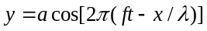

where the amplitude a is the same for both waves. (Assume x is much larger than d).

(i) Show that the two waves observed at an angle θ to a normal to the slits, have a resultant amplitude A which can be obtained by adding two vectors, each having magnitude , and each with an associated direction determined by the phase of the light wave.

Verify geometrically, from the vector diagram, that

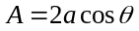

where

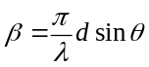

(ii) The double slit is replaced by a diffraction grating with N equally spaced slits, adjacent slits being separated by a distance d. Use the vector method of adding amplitudes to show that the vector amplitudes, each of magnitude a, form a part of a regular polygon with vertices on a circle of radius R given by
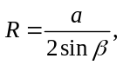
Deduce that the resultant amplitude is

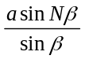

and obtain the resultant phase difference relative to that of the light from the slit at the edge of the grating.

(iii) Sketch, in the same graph, sin Nβ and (1/sinβ) as a function of β. On a separate graph show how the intensity of the resultant wave varies as a function of β.

(iv) Determine the intensities of the principal intensity maxima.
(v) Show that the number of principal maxima cannot exceed
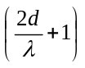

(vi) Show that two wavelengths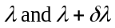, where δλ << λ, produce principal maxima with an angular separation given by
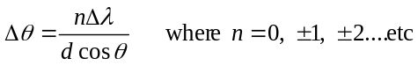

Calculate this angular separation for the sodium D lines for which

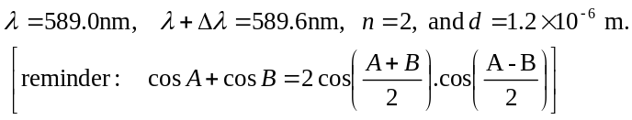

Q2
O
International Physics Olympiad 1956
2. Early this century a model of the earth was proposed in which it was assumed to be a sphere of radius R consisting of a homogeneous isotropic solid mantle down to radius R_{c}. The core region within radius R_{c} contained a liquid. Figure 2.1
E
X
R
Figure 2.1
R_{C}
2θ
R

The velocities of longitudinal and transverse seismic waves P and S waves respectively, are constant, V_{P}, and V _{S} within the mantle. In the core, longitudinal waves have a constant velocity V_{CP}, < V_{P}, and transverse waves are not propagated.
An earthquake at E on the surface of the Earth produces seismic waves that travel through the Earth and are observed by a surface observer who can set up his seismometer at any point X on the Earth’s surface. The angular separation between E and X, 2θ given by
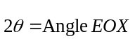
where O is the centre of the Earth.
(i) Show that the seismic waves that travel through the mantle in a straight line will arrive at X at a time t (the travel time after the earthquake), is given by

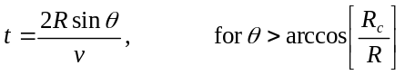,
where v = v_{P} for the P waves and v = v_{S} for the S waves.

(ii) For some of the positions of X such that the seismic P waves arrive at the observer after two refractions at the mantle-core interface. Draw the path of such a seismic P wave. Obtain a relation between θ and i, the angle of incidence of the seismic P wave at the mantle-core interface, for P waves.

(iii) Using the data
R | = | 6370 km
R_{C} | = | 3470 km
v_{CP} | = | 10.85 km | s⁻¹
v_{S} | = | 6.31 km | s⁻¹
v_{CP} | = | 9.02 km | s⁻¹
and the result obtained in (ii),draw a graph of θ against i. Comment on the physical consequences of the form of this graph for observers stationed at different points on the Earth's surface.
Sketch the variation of the travel time taken by the P and S waves as a function of θ for 0 θ 90 degrees.
(iv) After an earthquake an observer measures the time delay between the arrival of the S wave, following the P wave, as 2 minutes 11 seconds. Deduce the angular separation of the earthquake from the observer using the data given in Section (iii).

(v) The observer in the previous measurement notices that some time after the arrival of the P and S waves there are two further recordings on the seismometer separated by a time interval of 6 minutes 37 seconds. Explain this result and verify that it is indeed associated with the angular separation determined in the previous section.

Q3

Three particles, each of mass m, are in equilibrium and joined by unstretched massless springs, each with Hooke’s Law spring constant k. They are constrained to move in a circular path as indicated in Figure 3.1.

u₃
k
Figure 3.1
u₁
u₂
k
m
m
m
k

(i) If each mass is displaced from equilibrium by small displacements u₁, u₂ and u₃ respectively, write down the equation of motion for each mass.
(ii) Verify that the system has simple harmonic solutions of
the form
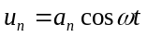,

with accelerations, 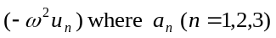are constant amplitudes, and ω, the angular frequency, can have 3 possible values,
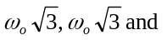0. where 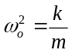.
(iii) The system of alternate springs and masses is extended to N particles, each mass m is joined by springs to its neighbouring masses. Initially the springs are unstretched and in equilibrium. Write down the equation of motion of the nth mass (n = 1,2...N) in terms of its displacement and those of the adjacent masses when the particles are displaced from equilibrium.

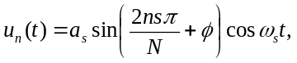
are oscillatory solutions where s = 1, 2,...N , n = 1, 2, ...N and where is an arbitrary phase,
providing the angular frequencies are given by
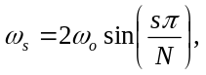
where 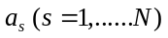are constant amplitudes independent of n.
State the range of possible frequencies for a chain containing an infinite number of masses.

(iv) Determine the ratio
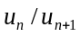
for large N, in the two cases:
(a) low frequency solutions
(b)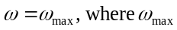is the maximum frequency solution.
Sketch typical graphs indicating the displacements of the particles against particle number along the chain at time t for cases (a) and (b).

(v) If one of the masses is replaced by a mass m' << m estimate any major change one would expect to occur to the angular frequency distribution.
Describe qualitatively the form of the frequency spectrum one would predict for a diatomic chain with alternate masses m and m' on the basis of the previous result.
Reminder
